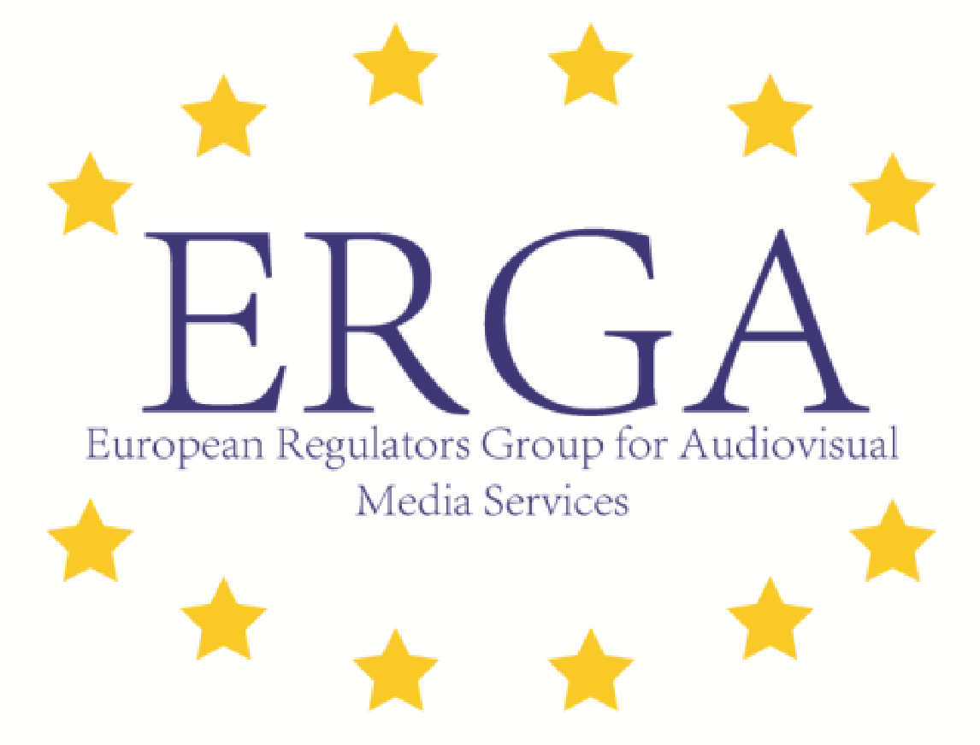

January 11, 2016  
 **Statement of the European Regulators Group for Audiovisual Media Services (ERGA) on the necessity of independent media***All EU Member States have committed themselves to abide by the European Convention on Human Rights and the EU Charter of Fundamental Rights, including by respecting the freedom and pluralism of the media. Any restrictions of that freedom risk undermining the independence of media. An independent media is the cornerstone of our European democracies, enabling citizens to form their own opinions and not be steered in one way or another by any stakeholder, including the state.*   
  
On January 7, 2016 a new law came into force in Poland on public service media which features new measures depriving the independent national authority, the KRRiT, of the power to nominate and dismiss the management and supervisory boards of the public service broadcasters, and transferring this power to the Minister of State Treasury. The new legislation also terminates the tenure of the current management and supervisory board members with immediate effect. All members of the new management and supervisory boards of the public service broadcasters will be appointed at the sole discretion of the Minister of State Treasury, without any requirement to ensure a plurality of representation. There will be no defined terms of office, and members may be dismissed by the Minister of State Treasury at any time at his/her discretion.   
  
These recent developments, and the expressed intentions of the Polish government to influence the programming of public broadcasters, raise serious concerns about the safeguarding of independent media in the European Union. They also make clear that the protection of independent media throughout Europe cannot be taken for granted, and requires continuous attention by all relevant institutions.   
  
In 2015 the European Regulators Group for Audiovisual Media Services (ERGA) issued a statement stressing the importance of the crucial role played by audiovisual media in guaranteeing freedom of expression, in promoting the free flow of information and ideas, in helping people to take decisions with full knowledge of the facts and in contributing to and strengthening democracy.[1] ERGA recalls this statement and in addition stresses that open and non-political procedures for the nomination, appointment, and removal of key players within audiovisual media are important tools to safeguard this role.   
  
Independent media also requires the strong shelter of independent oversight against undue commercial and state intervention. In its statement adopted in October 2014[2] as well as in its recent report on the independence of audiovisual media regulators[3], ERGA has recommended that the upcoming review of the Audiovisual Media Services Directive include stronger safeguards for the independence of national regulatory authorities, as a means of protecting our free and open societies. The recent developments in Poland only serve to underline the importance of this recommendation.   
  
ERGA calls upon all Member States of the European Union to act to uphold the principle of independence of the media across all European Member States. ERGA welcomes the actions already taken by the European Commission and calls on it to continue to actively monitor developments and to take *all* necessary steps to support a free and independent media, including the taking of firm action against the weakening of the necessary institutional arrangements.

1. http://ec.europa.eu/newsroom/dae/document.cfm?action=display&doc_id=9350
2. http://ec.europa.eu/newsroom/dae/document.cfm?doc_id=7310.
3. https://ec.europa.eu/digital-agenda/news-redirect/28179